# Casa and Elementary Uniform Information

**Dear Parents,**

Thank you for registering your child in the Casa or Elementary program at Silver Temple Theatre (STT). Casa and Elementary children are required to wear uniform daily, please see the uniform information below.

**Senior Casa/Elementary Formal Uniform – worn on Mondays only**

# Girls

* double box pleated tunic - grey, crested
* Long-sleeved cap blouse
* short-sleeved cap blouse-optional, May 1st – Oct. 15th only

*Please note – the polo shirt is not part of the girls’ uniform

* burgundy cardigan, crested
* charcoal grey high socks/tights
* black shoes (not running shoes) – please purchase elsewhere

# Boys

* grey dress pants
* long sleeved white polo shirt, crested
* short sleeved white polo shirt, crested - optional, May 1st – Oct. 15th only
* grey dress walking shorts (official STT uniform shorts only) – optional May 1st – Oct. 15th only
* burgundy cardigan, crested
* charcoal grey socks
* black shoes (not running shoes) – please purchase elsewhere

# Gym Uniform – Elementary, Senior Casa, Junior Casa and Pre-Casa -worn all day on all days (except for Mondays for Senior Casa and Elementary when students wear the formal uniform):

**Boys and Girls** – STT burgundy jogging pants, STT sweatshirt and STT shorts, and white STT t-shirt. If your child would like to wear a non-uniform shirt under their uniform, it must be white.

Junior and Pre-Casa students wear the gym uniform every day. Senior Casa students wear their formal uniform on Monday (unless it is their gym day and then they wear their gym uniform). The rest of the week they will wear their gym uniform.

Students will require at least two sets of the gym uniform.

**Sincerely,**

Admin Staff

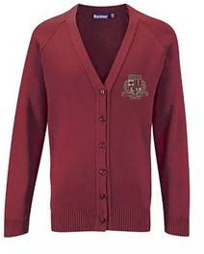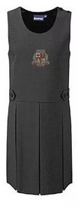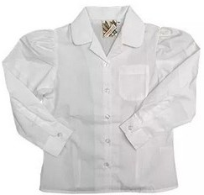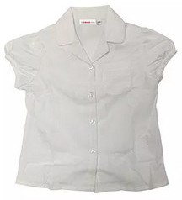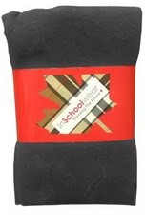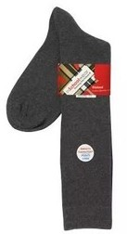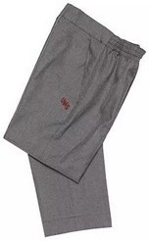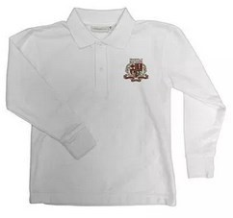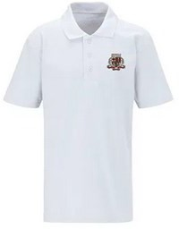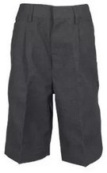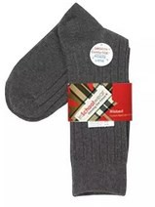

**Girls- Elementary, Senior Casa** Formal Uniform worn on Mondays only:

tunic - grey, crested

long-sleeved Katie collar white blouse

short-sleeved Katie collar white blouse - optional, May 1st – Oct. 15th only **\*Please note – the polo shirt is not part of the girls’ uniform**

burgundy cardigan, crested

charcoal grey socks/tights

black shoes (not running shoes) – please purchase elsewhere

**Double Box Pleat Tunic**

$53.00 approx.

**Cap Sleeve Blouse Long Sleeve**

$25.00 approx.

**Cap Sleeve Blouse Short Sleeve (optional)**

$25.00 approx.

**Cardigan**

$53.00 approx.

**Grey Girl Tights**

$20.00 approx.

**Grey Girl Knee High Socks**

$7.00 approx.

**Boys- Elementary, Senior Casa** Formal Uniform worn on Mondays only:

grey dress pants

long sleeved white polo shirt, crested

short sleeved white polo shirt, crested - optional, May 1st – Oct. 15th only

grey dress shorts (official UMS uniform shorts only) – optional May 1st – Oct. 15th only

burgundy cardigan, crested

charcoal grey socks

black shoes (not running shoes) – please purchase elsewhere

**Dress Pants**

$40.00-$45.00 approx.

**Polo Shirt Long Sleeve**

$29.00 approx.

**Polo Shirt Short Sleeve**

(optional)

$29.00 approx.

**Walking Shorts**

(optional)

$40.00-$46.00 approx.

**Cardigan**

$53.00 approx.

**Grey Ripped Socks**

$7.00 approx.

# Casa and Elemtentary Uniform Shopping Checklist

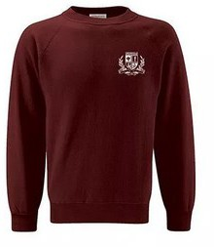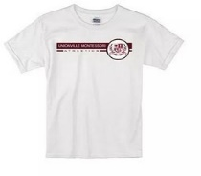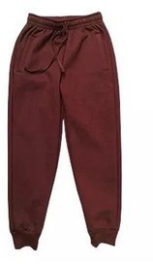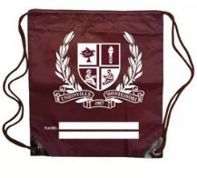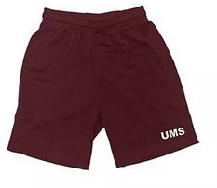

**Mandatory Elementary, Pre, Junior and Senior Casa Daily Uniform:**

Crewneck Sweatshirt (Mandatory)

Gym T-Shirt (Mandatory)

Sweatpants (Cuffed bottom) Mandatory

Mandatory Gym Bag (to keep extra clothing at school)

Coolmax Gym Shorts (optional)

White athletic socks (purchased from anywhere)

Running shoes with no laces and non-marking soles (purchased from anywhere)

**Crewneck Sweatshirt**

$48.00 approx.

**Gym T-Shirt**

$16.00 approx.

**Sweatpants (cuffed bottom)**

$32.00 approx.

**Gym Bag**

**(for extra clothing)**

$15.00 approx.

**Coolmax Gym Shorts (optional)**

$27.00 – $32.00 approx.